Investigation 9B: ¡EL NIÑO!

1. "Examine Figure 1, the neutral (long-term average or normal) conditions in the tropical Pacific Ocean from about Borneo in the western Pacific Ocean to the west coast of South America (greatly exaggerated in the vertical scale). The scene depicts the ocean surface with atmosphere above and a cross-section of the ocean below. Fair weather appears in the eastern tropical Pacific (near 80 degrees W) while the cloud diagram implies that ________ weather prevails in the western Pacific (near 120 degrees E)."
- fair
- stormy
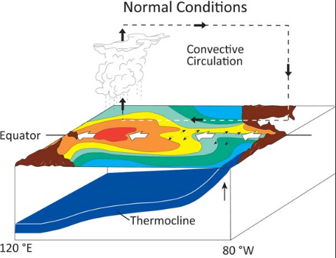

2. "The large-scale motions in the atmosphere show a convection cell (convective loop). The bold dark arrows show that air is rising in the stormy weather area of the western Pacific and ________ in the eastern tropical Pacific."
- rising
- sinking

3. "The bold black arrow along the ocean surface in the convective loop represents the trade winds and points in the direction toward which the prevailing winds are blowing in the equatorial region. As indicated by the arrows, winds during neutral (long-term average) conditions blow toward the ________ along the equator."
- east
- west

4. "The large white, open arrows provide surface ocean current information. The surface current arrows indicate that during neutral conditions, surface water flows towards the ________ driven by the prevailing winds."
- east
- west

5. "Colored areas on the top of the block diagram portion of the figure denote sea surface temperatures (SST) during neutral conditions. The red colored area in the western Pacific denotes the highest SST. These highest SST occur under ________ in the tropical Pacific. This SST pattern is caused by relatively strong trade winds pushing sun-warmed surface water westward, as indicated by the direction of surface current arrows."
- considerable cloudiness
- clear skies

6. "Strong trade winds also cause the warm surface waters to pile up in the western tropical Pacific so that the sea surface in the western Pacific is somewhat higher than in the eastern Pacific. Transport of surface waters to the west also causes the thermocline (the transition zone between warm surface water and cold deep water shown by the blue layer in the ocean side view) to be ________ in the eastern tropical Pacific than in the western Pacific."
- deeper
- shallower

7. "Warm surface water transported by the wind away from the South American coast is replaced by cold water rising from below in a process called upwelling. Upwelling of cold deep water results in relatively ________ SST in the eastern Pacific compared to the western Pacific."
- high
- low

8. "Cold surface water cools the air above it, which leads to increases in the surface air pressure. Warm surface water adds heat and water vapor to the atmosphere, lowering the surface air pressure. These air-sea interactions result in tropical surface air pressure being highest in the ________ tropical Pacific."
- eastern
- western

9. "Whenever air pressure changes over distance, a force will move air from where the pressure is relatively high to where pressure is relatively low. The trade winds blow from east to the west because from east to west the surface air pressure ________."
- increases
- decreases

10. "Rainfall in the tropical Pacific is also related to SST patterns. There are reasons for this relationship. The higher the SST, the greater the rate of evaporation of seawater and the more vigorous the atmospheric convection. Consequently, during neutral conditions, rainfall is greatest in the western tropical Pacific where SST are ________."
- highest
- lowest

11. "Figure 2 shows atmospheric and oceanic conditions during El Niño. Compared to Figure 1 (neutral or long-term average conditions), the area of stormy weather during El Niño has moved ________. While no two El Niño episodes are exactly alike, all of them exhibit most of the characteristics shown in the El Niño schematic of Figure 2. With the onset of El Niño, tropical surface air pressure patterns change. Compare El Niño conditions in the western and central tropical Pacific with the neutral conditions of Figure 1. During neutral conditions, surface air pressure in the central Pacific is higher (accompanied by fair weather) than to the west. During El Niño, the surface air pressure to the west is higher than in the central Pacific. This reversal in the atmospheric pressure pattern, called the southern oscillation, was first studied in an attempt to explain monsoon failure and drought in India.
- eastward
- westward

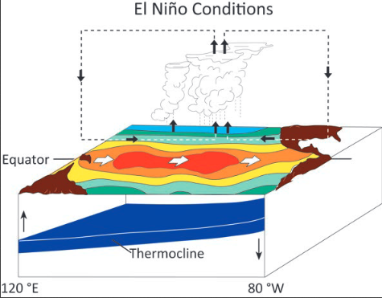

12. "In response to changes in the air pressure pattern across the tropical Pacific, the trade winds weaken (and wind directions can reverse, especially in the western Pacific as shown by the bold dark arrows). No longer being pushed toward and piled up in the western Pacific, the warm surface water reverses flow direction. As shown by the surface currents arrows, the surface water during El Niño flows toward the east. As evident in the appropriate sea surface temperature shading, this causes SST in the eastern tropical Pacific to be ________ than during neutral conditions."
- higher
- lower

13. "In response to changes in surface currents, sea surface heights in the eastern tropical Pacific are higher than during neutral conditions. At the same time, the arrival of the warmer water in the east causes the surface warm-water layer to thicken. Evidence of this is the ________ depth of the thermocline to the east compared with neutral conditions."
- shallower
- deeper

14. "Figure 3 shows atmospheric and oceanic conditions during La Niña. At times the tropical Pacific experiences trade winds stronger than neutral conditions with SST lower than usual in the eastern tropical Pacific and higher than usual in the western tropical Pacific. Because stronger trade winds produce stronger surface currents during La Niña, the warm water is pushed westward and colder water wells up to cause below-average SST in the eastern tropical Pacific. It also follows that SST in the western tropical Pacific must be ________ than during a typical El Niño episode."
- higher
- lower

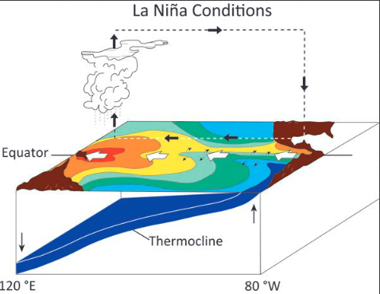

15. "Changes in surface air pressure, areas of large-scale convection, and upper air flow patterns as shown in Figures 2 and 3 alter the planetary wind circulation and affect the weather elsewhere in the world. Figure 4 shows some weather patterns that have been statistically associated with El Niño conditions. This figure shows that during our Northern Hemisphere winter when El Niño is taking place, the southeastern states are usually ________ than normal. Figure 5 shows some weather patterns linked to La Niña conditions."
- drier and warmer
- wetter and cooler

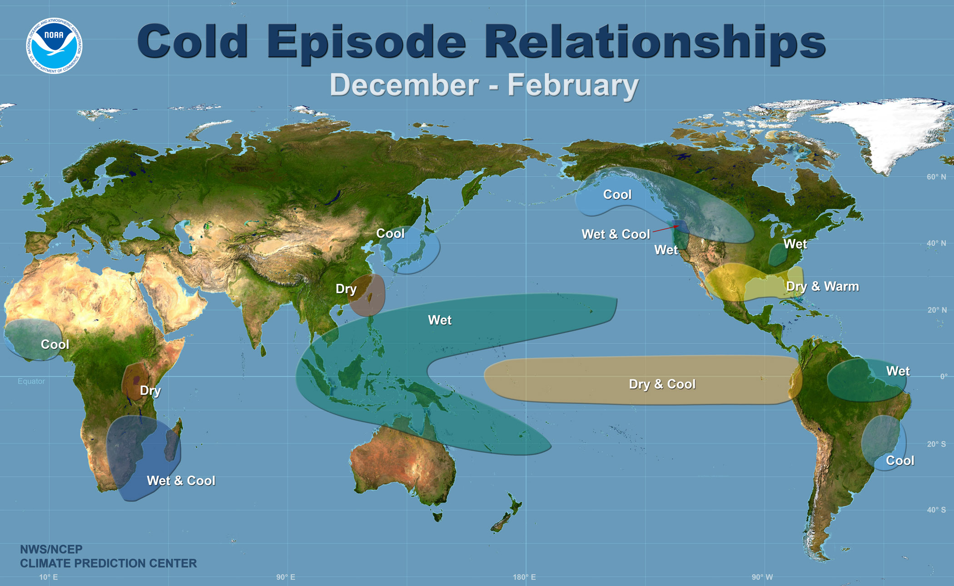

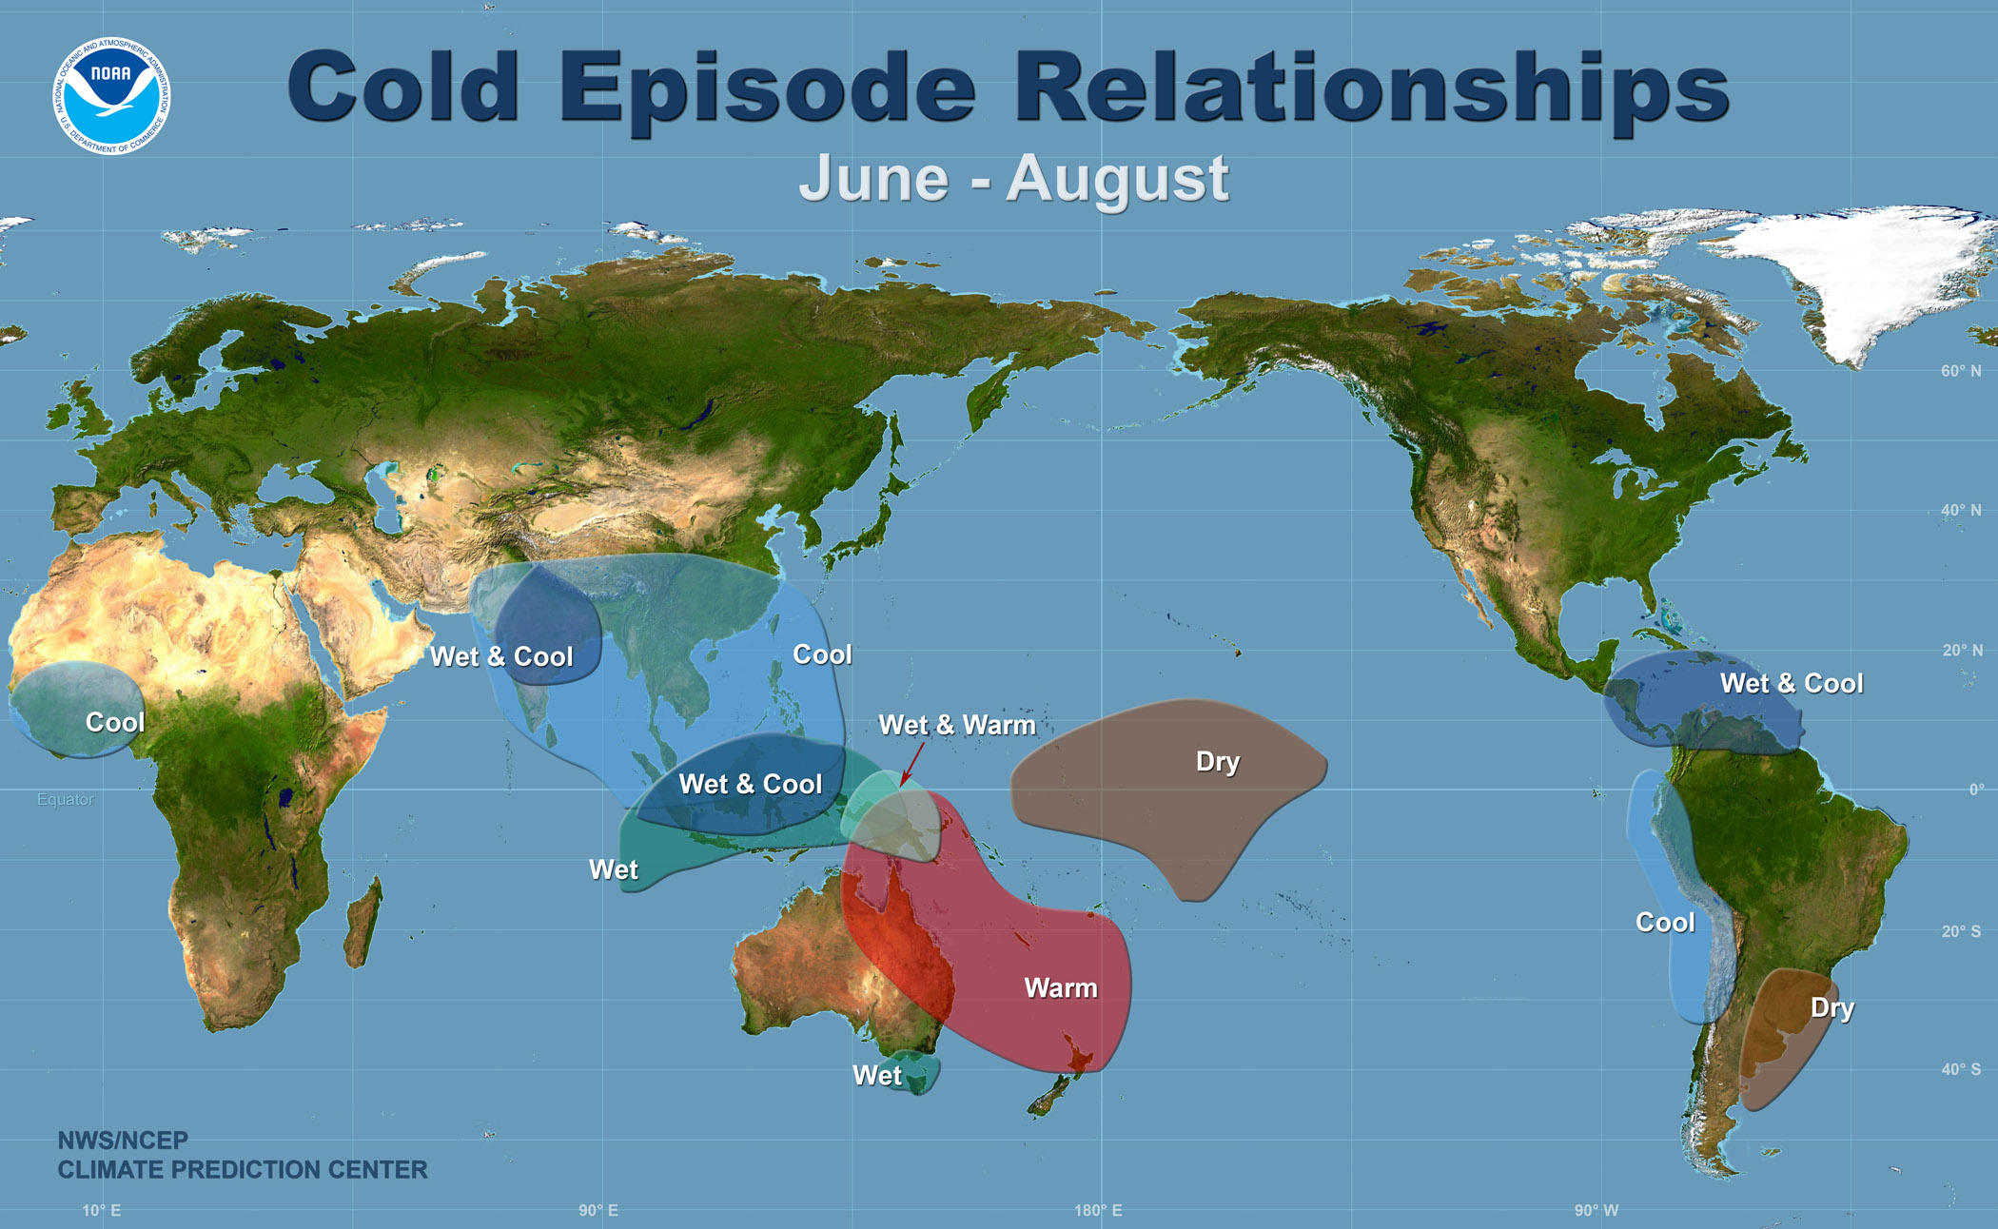

Applications

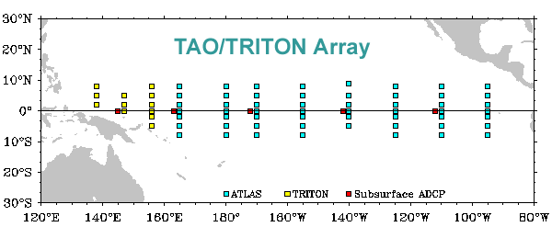

16. "The most recent reporting of TAO surface data at this writing is presented in Figure 7. The upper panel of Figure 7 depicts the five-day mean tropical Pacific sea surface temperatures (SST) and wind conditions ending on November 3, 2015. The SST are represented with isotherms drawn at half-Celsius degree intervals and color shading indicated by the right-side scale. Wind directions are shown by arrows originating at the buoy sites while the lengths of the arrows depict the relative wind speeds. The shading and isotherms indicate that the warmest waters across the tropical Pacific are located near ________ longitude. [Note, the Pacific east of 180° longitude (generally the International Dateline) has W(est) numbered longitudes while the Pacific west of 180° has E(ast) numbers measured west and east, respectively, from the Prime Meridian.
- 155° E
- 175° W
- 115° W

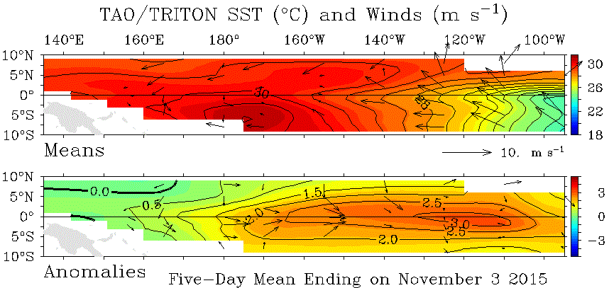

17. "Across most of the tropical Pacific, the winds were directed generally from ________ and are strongest in the eastern Pacific."
- west to east
- east to west

18. "Considering the isotherms and the shading scale for temperature anomalies to the right, the magnitudes in the greatest positive SST anomalies are between ________ Celsius degrees."
- 1.0 and 2.0
- 2.0 and 3.0
- 3.0 and 3.5

19. "The location of the greatest positive SST anomalies was about ________ longitude."
- 160° E
- 160° W
- 120° W

20. "The broad pattern of current SST anomalies across the tropical Pacific region, in general, shows values that are: ________."
- negative across nearly the entire equatorial Pacific
- positive across nearly the entire equatorial Pacific
- negative over eastern half of the region and positive over the western half
- positive over eastern half of the region and negative over the western half

21. "The anomalous winds along the equator across the tropical Pacific were generally ________ across the tropical Pacific."
- all strongly from the east
- all strongly from the west
- either very light or from the east
- either very light or from the west

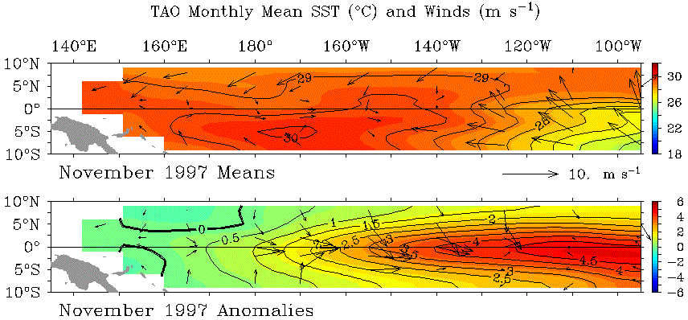

22. "The top view of Figure 8, November 1997 Means, displays the average SST and surface winds for the month of November 1997. The sea surface temperatures across the region ranged from about 26 °C as the “coolest” in the southeast corner to about 30 °C as the “warmest” just south of the Equator. These highest SST were located at about ________ longitude in the tropical Pacific."
- 170° W
- 120° W

23. "The wind directions in the eastern Pacific were generally from the southeast. In the western Pacific, along the Equator (between about 140° E and 150° W), winds were generally light with most blowing from the west. Compare these observed winds and SST in Figure 8 with the depiction in Figure 2, where surface winds are the horizontal black arrows and the SST are color coded. The observations and the schematic model generally ________ consistent.
- are
- are not

24. "The SST anomalies in the eastern Pacific were positive, with the greatest values being slightly more than ________ C°. SST anomalies along the equator were also almost all positive. The location, degree and duration of the warm SST anomalies are what define the El Niño situation."
- 1.5
- 4.5
- 7.5

25. "Now examine Figure 9. These are the tropical Pacific average SST and wind conditions for November 1998, one year after Figure 8, showing that La Niña conditions had replaced El Niño. For November 1998, the sea-surface temperatures along the Equator in the eastern Pacific were near 22 °C, several degrees ________ than those of the same area during the El Niño in November 1997. The winds across the entire Pacific area (Figure 9 Means) were generally blowing from east to west at that time. The warmest waters were found in the extreme western Pacific."
- warmer
- cooler

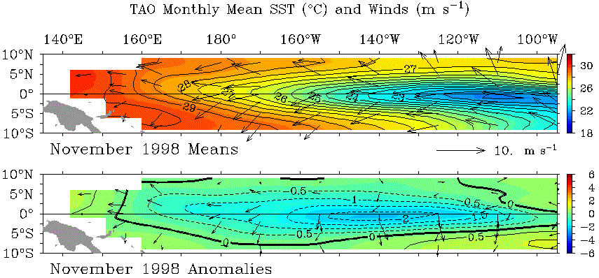

26. "These observed winds and SST in November 1998 generally ________ consistent with the depiction of those in Figure 3 of this activity for a La Niña."
- are
- are not

27. "The lower panel of November 1998 Anomalies shows the Pacific SST anomalies along the Equator being almost all negative, denoted by the dashed lines, with negative departures dropping below ________ C°. This relatively cool [compared to the long-term average or Neutral (“Normal”) Conditions] water is characteristic of La Niña."
- –2
- –3

28. "Examine the SST anomaly field in the critical region box you drew, and estimate its average anomaly temperature. The average SST anomaly of the box area shows that the November 2015 tropical Pacific pattern is consistent with ________ conditions."
- La Niña
- El Niño

29. The CPC discussion and SST and wind anomalies of Figure 7 best match the existence of ________ conditions. For the several months prior to November 2015, above-normal temperatures (positive anomalies) had covered most of the equatorial Pacific. The forecast suggested that those warm conditions may remain El Niño conditions through winter of 2015-16. This expectation comes from a consensus of the ocean-atmosphere indicators and ENSO numerical models."
- La Niña
- El Niño

